## Reports/ Third Party Report/ OffLine Reversal Report:

Request:

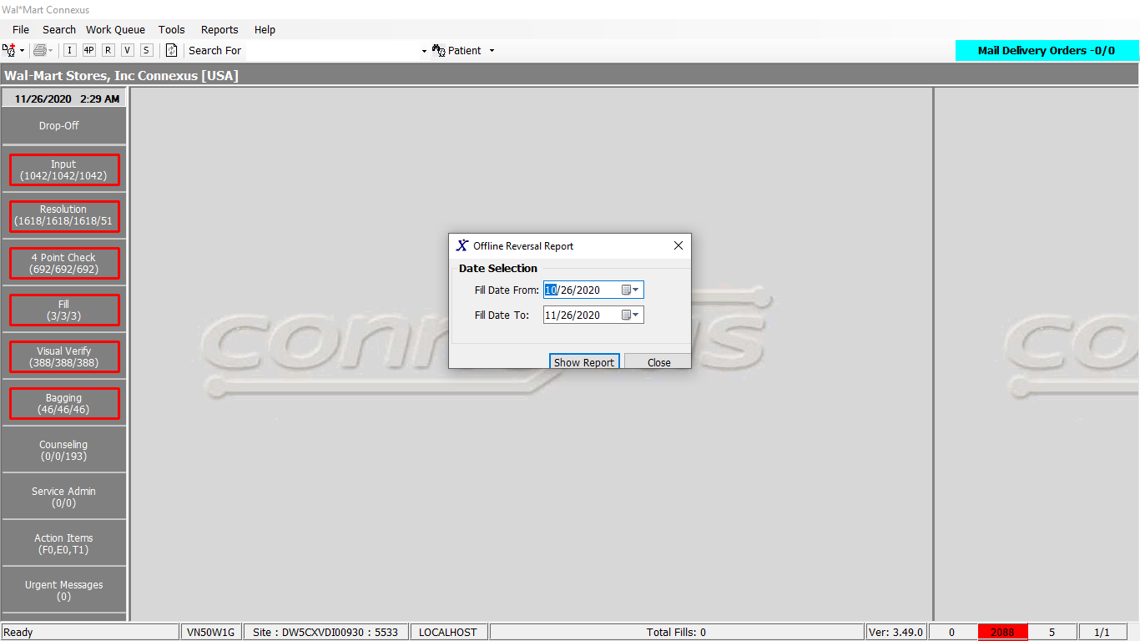

Response:

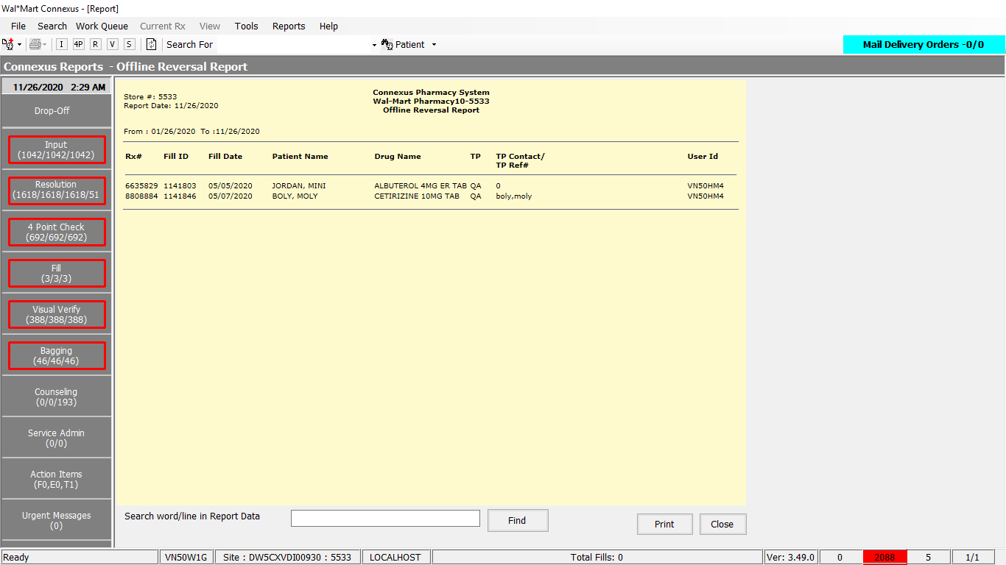

Queries:

Friend Const GetOffRevReportSelect As String = "SELECT rx.rx_nbr, TRIM(NVL(pa.last_name,'')) || ', ' || TRIM(NVL(pa.first_name,'')) || ' ' || TRIM(NVL(pa.middle_name,'')) PatientName, pp.short_name, rxf.rx_fill_id, rxf.fill_date, cr.claim_reference_id ref_id, cr.last_chg_userid userid, cr.response_msg_txt TPName, pc.phm_co_name_abbr TP FROM rx rx, rx_fill rxf, rx_sale_detail rsd, phm_company pc, claim_response cr, patient pa, rx_fill_item rfi, pharmacy_offering: pharmacy_product pp, pharmacy_offering: pharmacy_item pi Where rx.patient_id > 0 AND rsd.rx_fill_id = cr.rx_fill_id AND cr.response_code = 1908 AND pc.phm_co_id = rsd.aff_party_id AND rsd.status_code = 21009 AND rx.rx_nbr IS NOT NULL AND rx.patient_id = pa.patient_id AND rxf.rx_fill_id = cr.rx_fill_id AND rx.rx_id = rxf.rx_id And rx.rx_version_seq_nbr = rxf.rx_version_seq_nbr AND rxf.rx_fill_id = rfi.rx_fill_id And rfi.item_seq_nbr = 1 And rfi.item_mds_fam_id = pi.mds_fam_id AND pi.product_mds_fam_id = pp.product_mds_fam_id AND rxf.status_code = 20403 AND rxf.fill_date BETWEEN ? AND ? Order by fill_date, PatientName, rx_nbr "

DAL:

Public Function GetOffRevReport(ByVal siteId As Integer,

ByVal startDate As DateTime, ByVal endDate As DateTime) _

As List(Of GetOffRevReportInfoBE) Implements IReportDAL.GetOffRevReport

Using (New Tracer(ConnexusCommonConstants.ConnexusTracer))

Dim sqlString As String

Dim getOffRevReportInfoBEList As New List(Of GetOffRevReportInfoBE)

Dim paramList As New List(Of DbParameter)

sqlString = ReportQueries.GetOffRevReportSelect

paramList.Add(ParameterHelper.BuildParameter("fillDate", DbType.Date,

startDate))

paramList.Add(ParameterHelper.BuildParameter("fillDate", DbType.Date,

endDate))

Dim dataReader As IDataReader = ExecuteReader(DatabaseEnum.rx21c, siteId,

sqlString, paramList)

Dim getOffRevReportBE As New GetOffRevReportInfoBE

While dataReader.Read

getOffRevReportBE = New GetOffRevReportInfoBE

If Not dataReader.IsDBNull(dataReader.GetOrdinal("fill_date")) Then

getOffRevReportBE.FillDate = CDate(dataReader("fill_date"))

End If

If Not dataReader.IsDBNull(dataReader.GetOrdinal("PatientName")) Then

getOffRevReportBE.PatientName = CStr(dataReader("PatientName")).Trim

End If

If Not dataReader.IsDBNull(dataReader.GetOrdinal("ref_id")) Then

getOffRevReportBE.RefId = CInt(dataReader("ref_id"))

End If

If Not dataReader.IsDBNull(dataReader.GetOrdinal("rx_fill_id")) Then

getOffRevReportBE.RxFillId = CInt(dataReader("rx_fill_id"))

End If

If Not dataReader.IsDBNull(dataReader.GetOrdinal("rx_nbr")) Then

getOffRevReportBE.RxNbr = CInt(dataReader("rx_nbr"))

End If

If Not dataReader.IsDBNull(dataReader.GetOrdinal("short_name")) Then

getOffRevReportBE.ShortName = CStr(dataReader("short_name")).Trim

End If

If Not dataReader.IsDBNull(dataReader.GetOrdinal("TP")) Then

getOffRevReportBE.Tp = CStr(dataReader("TP")).Trim

End If

If Not dataReader.IsDBNull(dataReader.GetOrdinal("TPName")) Then

getOffRevReportBE.TpName = CStr(dataReader("TPName")).Trim

End If

If Not dataReader.IsDBNull(dataReader.GetOrdinal("userid")) Then

getOffRevReportBE.UserId = CStr(dataReader("userid")).Trim

End If

getOffRevReportInfoBEList.Add(getOffRevReportBE)

End While

If getOffRevReportInfoBEList.Count > 0 Then

Return getOffRevReportInfoBEList

Else

Return Nothing

End If

End Using

End Function